

Addendum for using testssl under windows



Welcome to the EDPB website auditing tool

# Install docker

Before installing the EDPB auditing tool, please make sure that Docker is already installed and active on your system. Follow these instructions to install docker on your system:

<https://docs.docker.com/desktop/install/windows-install/>

Once installed, open docker for the first time (from the system tray or the start menu).

Make sure that docker is active and in your path, by using the following line :

docker run --rm -ti drwetter/testssl.sh:3.0 https://example.com/

The output should look like this:

Once installed, download the following version of the EDPB auditing tool :

<http://bevara.ddns.net/audit/installer-1-with-docker/website-audit%20Setup%201.0.1.exe>

# Running testssl

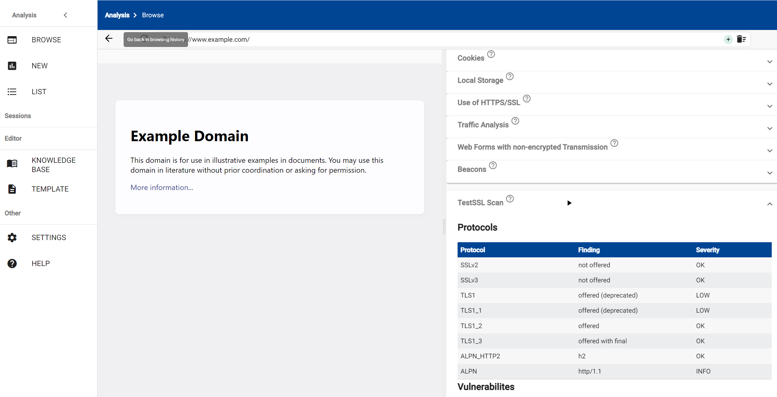

Testssl is now directly available inside the testSSL scan in the browse section.